Prvo pitanje
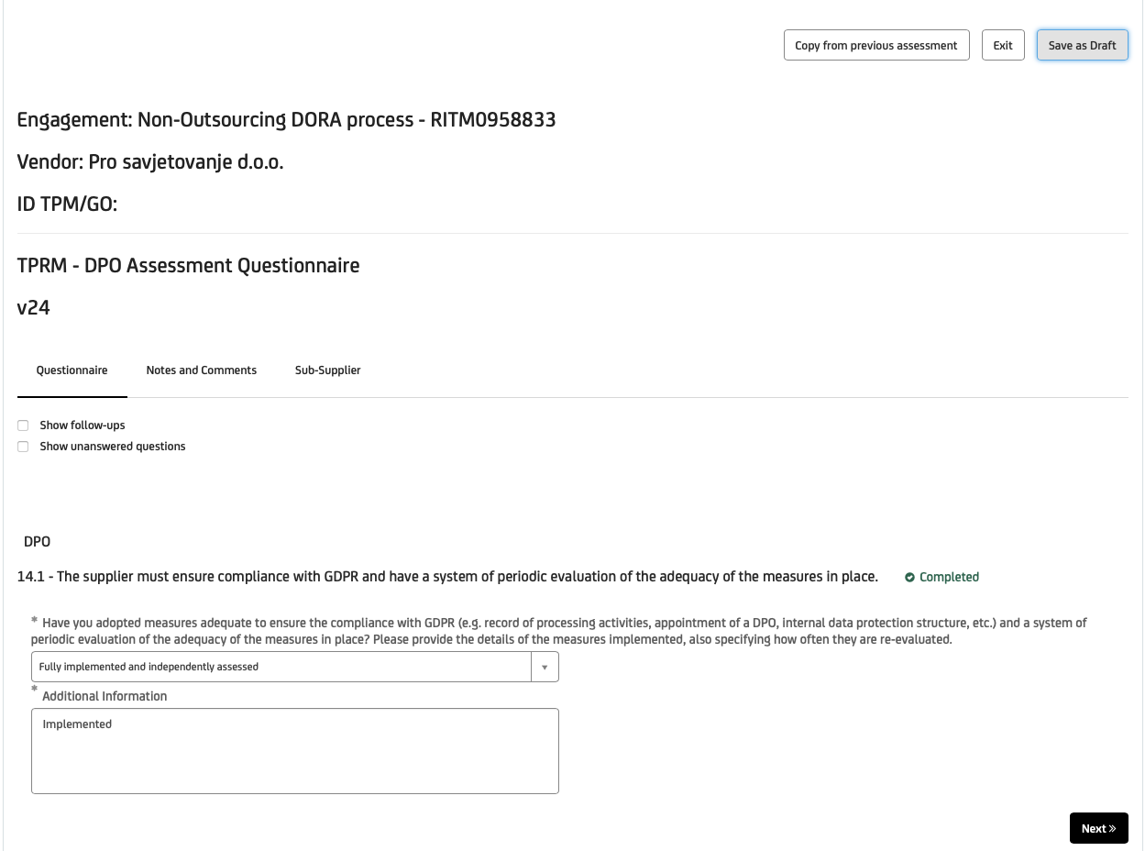

U dropdwon treba odabrati:

U odgovoru kopiraj ovaj tekst

Fintastic has implemented a comprehensive GDPR compliance framework aligned with Articles 5, 24, 30, 32 and 37–39 of the GDPR.

The implemented measures include:
- Maintenance of Records of Processing Activities (RoPA) for all relevant business processes;
- Appointment of a Data Protection Officer (DPO) with defined responsibilities and independence;
- Adoption of internal data protection policies and procedures (privacy policy, data subject rights handling, incident response);
- Risk-based approach to personal data processing, including Legitimate Interest Assessments (LIA) where applicable;
- Data protection by design and by default principles embedded in digital services and workflows;
- Vendor and third-party data protection assessments where personal data processing is involved;
- Employee awareness and GDPR training proportional to roles and access levels.

The adequacy and effectiveness of GDPR measures are reviewed periodically:
- On an annual basis as part of internal compliance review;
- Ad-hoc in case of regulatory changes, new processing activities, or significant ICT or organizational changes;

The GDPR framework is continuously improved based on audit findings, regulatory developments, and risk assessments.

Drugo pitanje,
Uz njega tablica Template_14.2

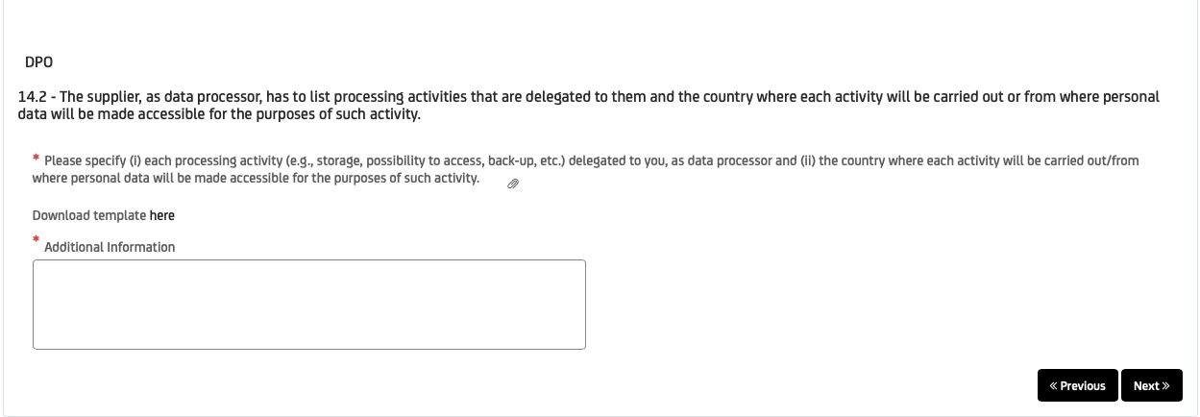

Ovo ide u polje Additional Information:

As a data processor, Fintastic processes personal data strictly based on documented instructions from the data controller and only for the purposes defined in the relevant contractual arrangements.
All processing activities delegated to Fintastic are documented in a dedicated processor-level Record of Processing Activities, including the description of activities, categories of data, access rights, and geographic location of processing.
Personal data processing activities are limited to:
- secure storage and controlled access to personal data;
- processing necessary for the provision of agreed professional and consulting services;
- back-up and availability assurance;
- technical and organizational safeguards ensuring confidentiality, integrity, and availability of data.

All processing activities are performed within the European Union. No personal data is transferred to or accessed from third countries outside the EU/EEA.

Further details on each processing activity, including purpose, type of processing and country of processing, are provided in the attached table.

Pitanje 3
Uz njega tablica Template_14.3.
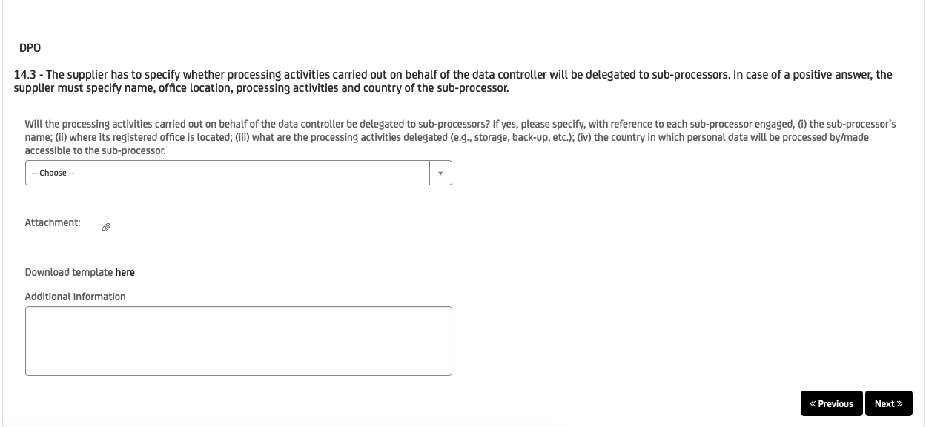

Tekst koji ide u polje Additional information:

Sub-processors are engaged only where strictly necessary to support the provision of services and only under documented contractual arrangements ensuring GDPR compliance.

All sub-processors are located within the European Union. No personal data is transferred to or accessed from third countries outside the EU/EEA.

Sub-processors are subject to appropriate contractual safeguards, including data protection obligations equivalent to those imposed on the supplier as a data processor. The list of sub-processors is reviewed periodically and updated as required.

Pitanje 4
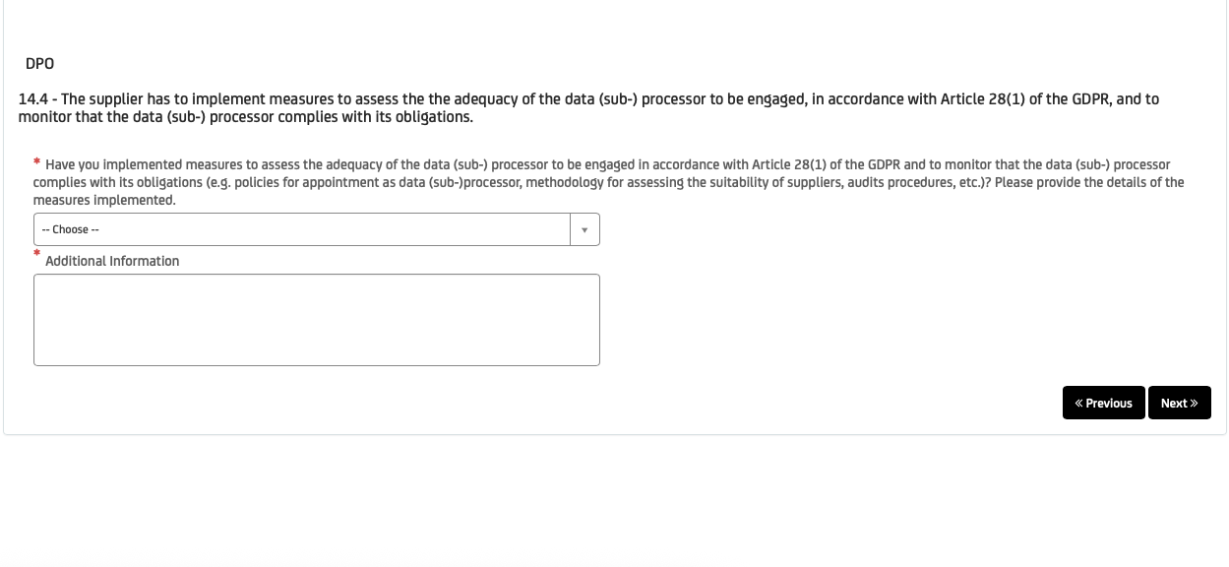

U dropdown listi odaberite YES

U Additional Information ide ovaj tekst:

The supplier has implemented measures to assess the adequacy and suitability of data (sub-)processors prior to engagement and to monitor their ongoing compliance with GDPR obligations, in line with Article 28(1) of the GDPR.

Sub-processor engagement is subject to a risk-based assessment that includes:
- verification of the sub-processor’s GDPR compliance framework and data protection commitments;
- assessment of data residency and geographic location of processing;
- review of technical and organizational measures relevant to confidentiality, integrity and availability of personal data;
- confirmation of appropriate contractual safeguards (including data processing agreements and standard data protection clauses).

Ongoing monitoring of sub-processors is performed through:
- periodic review of contractual and compliance documentation;
- monitoring of relevant regulatory, security or contractual changes;
- ad-hoc reassessment in case of significant changes to services, processing activities or applicable regulations.

Sub-processors are engaged only where necessary and only if they provide sufficient guarantees to implement appropriate technical and organizational measures ensuring GDPR compliance.

Pitanje 5
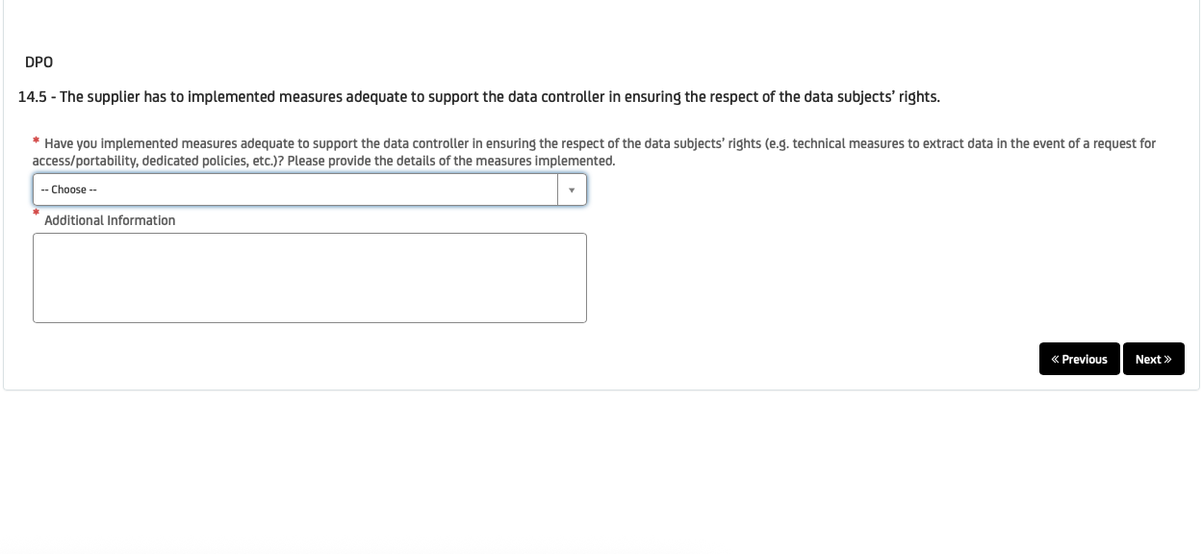

U dropdown listi odabrati YES

U Additional Information kopirati ovaj tekst:

The supplier has implemented measures to support the data controller in ensuring the effective exercise of data subjects’ rights, in accordance with Articles 12–23 of the GDPR.

As a data processor, the supplier acts solely on the documented instructions of the data controller and provides assistance as required, including:
- procedures for the identification, retrieval and extraction of personal data relevant to data subject requests (e.g. access, rectification, erasure, restriction, portability);
- technical and organizational measures enabling timely access to and secure transmission of relevant data to the data controller;
- internal procedures to ensure prompt notification and cooperation upon receipt of any data subject request;
- role-based access controls to ensure that only authorized personnel handle data related to data subject rights requests.

Requests from data subjects received directly by the supplier are promptly forwarded to the data controller without undue delay. Measures are reviewed periodically and updated as necessary to ensure continued compliance.

Pitanje 6
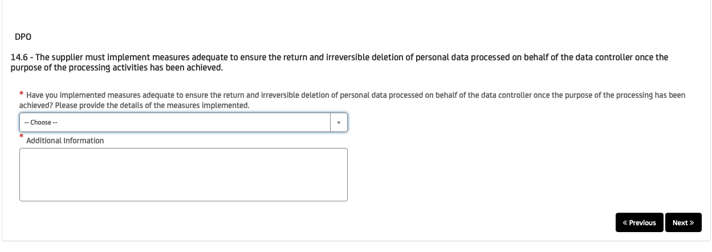

U dropdown odabrati YES

U Additional Information: The supplier has implemented measures to ensure the return and irreversible deletion of personal data processed on behalf of the data controller once the purpose of processing has been achieved or upon termination of the contractual relationship, in accordance with Article 28(3)(g) of the GDPR.

Measures include:
- documented data retention and deletion procedures aligned with contractual instructions from the data controller;
- controlled deletion of personal data from active systems, backups and repositories within defined timeframes;
- technical measures ensuring irreversible deletion, including secure deletion methods appropriate to the storage medium;
- procedures for the secure return of personal data to the data controller where requested;
- access controls and segregation of data to prevent further processing after deletion or return.

Deletion or return of data is performed based on documented instructions from the data controller and, where applicable, confirmed through internal records. Measures are reviewed periodically and updated as necessary.

Pitanje 7
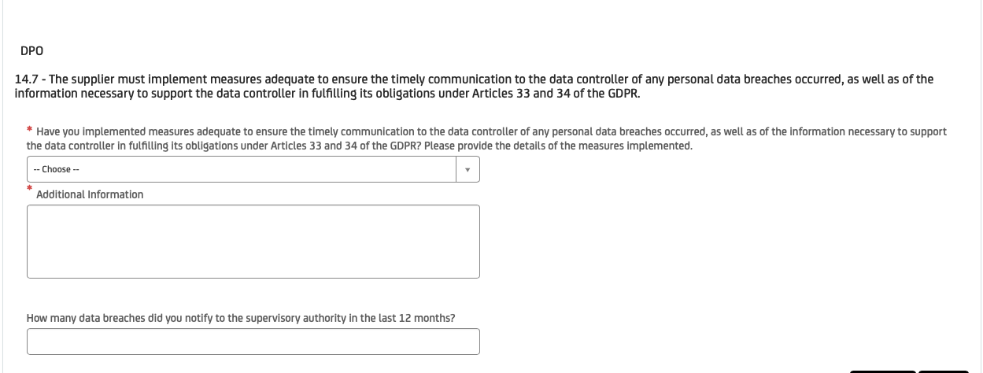

U dropdown listi odabrati YES

U Additional Information:
The supplier has implemented measures to ensure the timely communication to the data controller of any personal data breaches, as well as the provision of information necessary to support the data controller in fulfilling its obligations under Articles 33 and 34 of the GDPR.

Measures include:
- documented incident and personal data breach management procedures defining roles, escalation paths and timelines;
- internal processes to promptly identify, assess and classify potential personal data breaches;
- procedures to notify the data controller without undue delay after becoming aware of a personal data breach;
- structured collection and documentation of relevant information (nature of the breach, categories of data and data subjects affected, likely consequences, and mitigation measures);
- cooperation with the data controller to support regulatory notification and communication to data subjects where required.

The supplier does not notify supervisory authorities directly unless explicitly instructed by the data controller. Measures are reviewed periodically and updated as necessary.

Pitanje 8
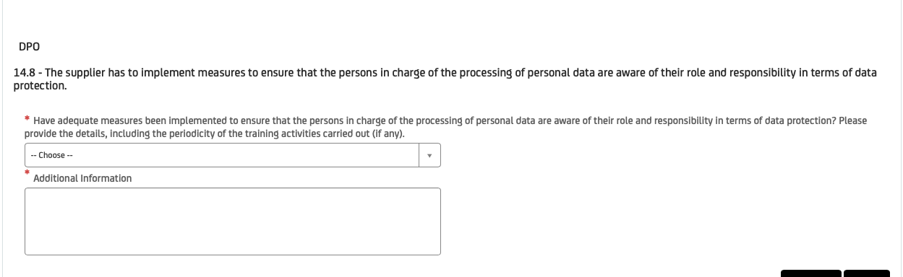

U dropdown listi odabrati YES

U Additional Information:

The supplier has implemented measures to ensure that all persons involved in the processing of personal data are aware of their roles and responsibilities in terms of data protection.

Measures include:
- definition of roles and responsibilities related to personal data processing, including confidentiality obligations;
- onboarding and role-based awareness activities for personnel with access to personal data;
- periodic data protection awareness and training activities, conducted at least annually and updated as necessary in case of regulatory or organizational changes;
- internal guidelines and procedures covering secure handling of personal data and incident escalation;
- reinforcement of data protection obligations through contractual confidentiality commitments.

Training and awareness activities are reviewed periodically and adapted based on changes in processing activities, applicable regulations or identified risks.

Pitanje 9
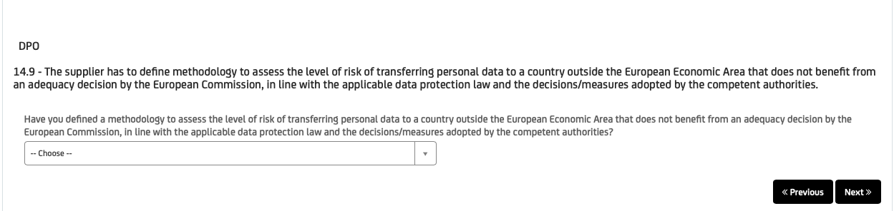

Ovdje treba odabrati YES

Ne vidim Additional Infromation, ali ako ima treba upisati sljedeće:

The supplier has defined a methodology to assess the level of risk associated with the transfer of personal data to countries outside the European Economic Area that do not benefit from an adequacy decision by the European Commission.

The methodology is aligned with applicable data protection law and relevant decisions and guidance of competent authorities and includes:
- identification of the nature and scope of the personal data to be transferred;
- assessment of the destination country and applicable legal framework;
- evaluation of appropriate transfer safeguards, such as Standard Contractual Clauses (SCCs);
- assessment of the need for supplementary technical and organizational measures;
- documentation of the assessment and decision-making process.

Currently, the supplier does not transfer personal data to third countries outside the EU/EEA. The methodology is applied where relevant and reviewed periodically or in case of changes to processing activities or regulatory requirements.

Pitanje 10
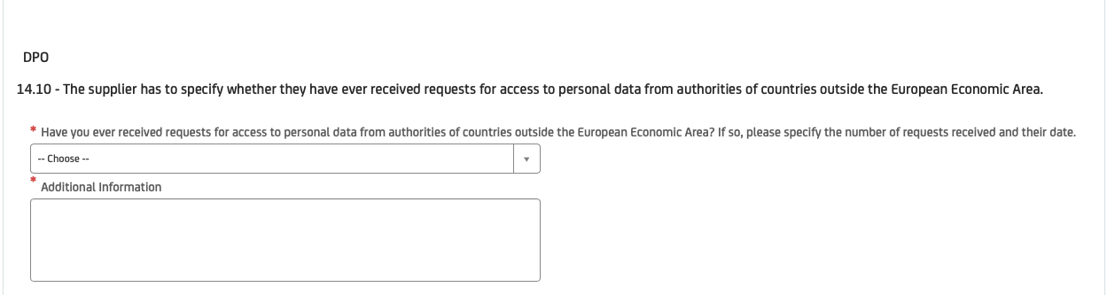

Ovdje je potrebno odabrati NO

U Additional Information unijeti:

The supplier has never received any requests for access to personal data from authorities of countries outside the European Economic Area.

In the event that such a request were to be received, the supplier would assess the request in accordance with applicable data protection law and promptly inform the data controller, in line with contractual and regulatory obligations.

